**Project 7:How to download and run project from github**

* **Git bash to install and start the reactjs**

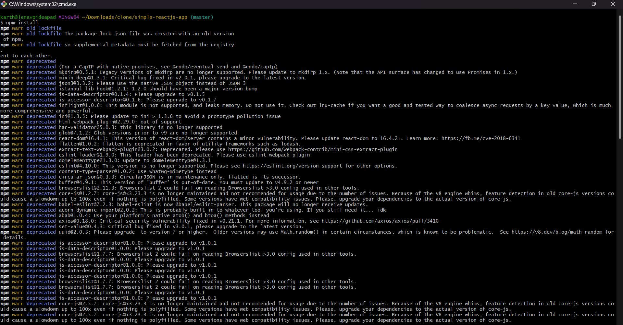

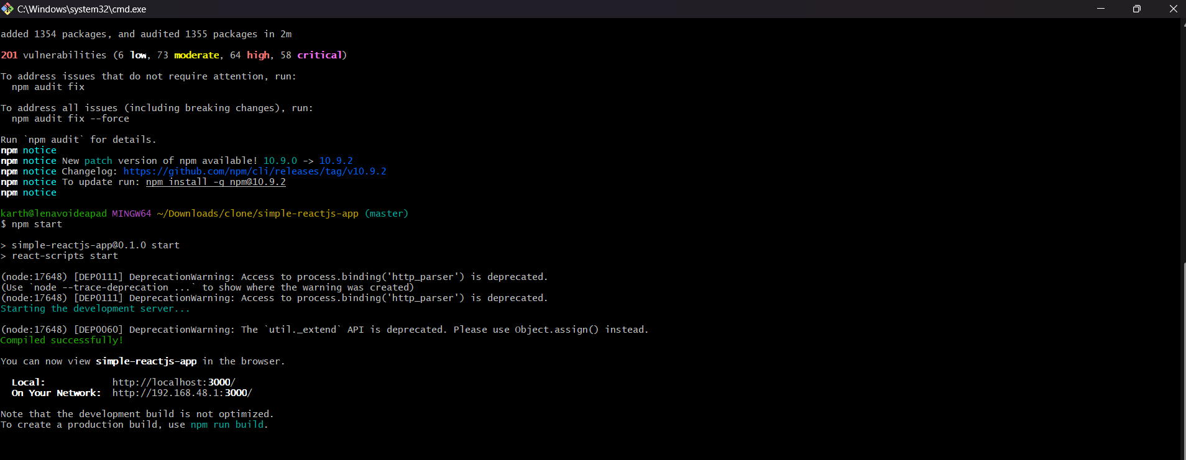

* **Create Git hub repository as simple-reactjs-app**

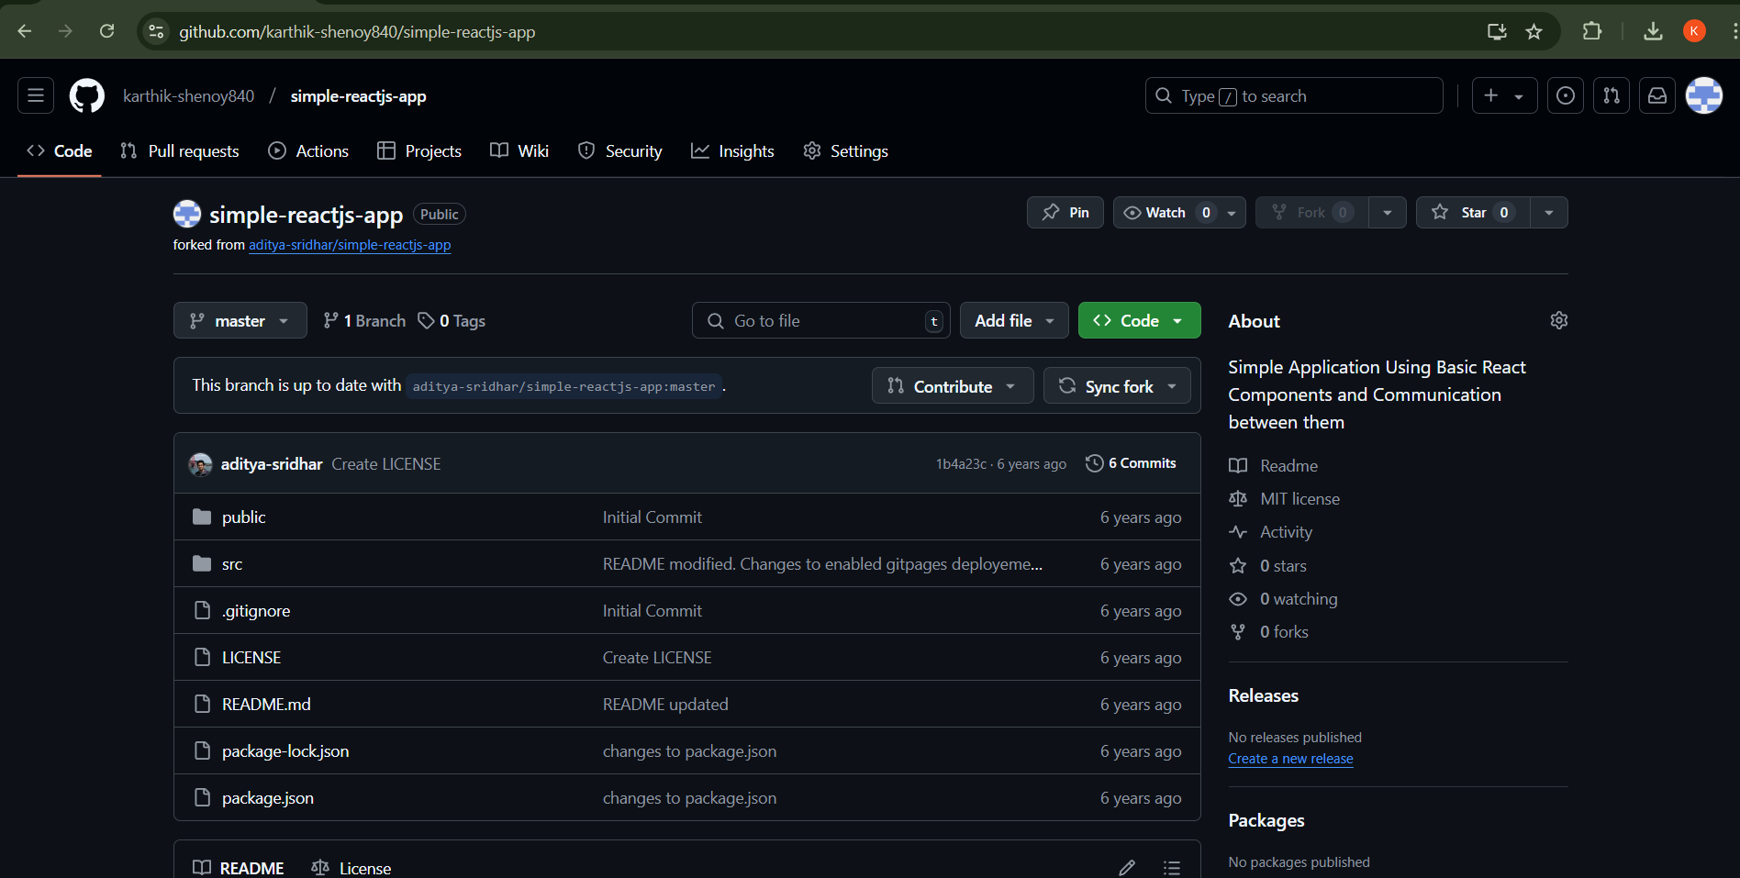

* **Final output**

